Assignment GISC 424 Lab 6

Name: Pawaneet Kaur

ID: 300516023

1. How many trees have been removed between the Lidar survey and our field trip? Produce a report using ENVI showing your methodology (10 points)

Method: I overlay/clipped the LIDAR tree crown polygon (2013) with the drone tree crown raster image (2020).

Steps:

1) convert the 2013 area of interest cloud data to DEM and DSM in LIDAR ENVI.

2) generate tree crown point and polygon via python Pycrown library (Jupiter notebook)

3) tree present 2013= count how many trees are removed

4) subtract DSM 2013 - DSM 2020 = BAND MATH = GRAY SCALE, OVERLAY (Figure 2)

5) count the tree crown point overlaying the black/ white (not the grey) region within the drone captured image area (Figure 2).

Or you can build a layer stack with DEM 2013, DSM 2013, WAIHOA-65m-FLT05-HQ.tif, to generate:

Band1 = DSM 2020, band 2= DSM 2013, Band 3= DEM 2013 (Figure 1); whereby counting the tree crown point overlaying the green area within the 2020 DSM zones.

Results/conclusion: 20-40 trees have been removed since 2013 in comparison to 2020; small area makes it easier to remove trees.

1. Describe how you would go about automating this method for a larger area? (10 points)

Large area: create polygon shape file from tree crown area (2020) via PyCrown.

I will then find the removed vegetation (from 2013-2020):

1. via spatial join tool – overlaying 2013 and 2020 tree polygon.
2. intersecting both 2013 and 2020 tree crown center points – Areas outside 2020 tree crown polygon indicate tree loss.
3. There is an offset between the RPAS measured elevation data and the drone measured elevation data. What is that offset? How did you measure it (10 points)?

* I subtracted the DSM 2020 (drone) with DSM 2013 (RPAS/LIDAR) to find the offset (about 12.5-12.75) vertical difference between ground and drone data. The DSM feature has a high resolution (due the small pixel size 1 (x) by 1 (y) meters); thus, the offset does not change.

1. Unlike LIDAR, RPAS SFM (drone) cannot produce a DTM since it doesn’t penetrate the canopy. What would be our next best way to produce a CHM for 2020?

the CHM (2020) can be generated by 1) find the DEM 2020 via Band math = (DSM 2020 – DSM 2013) + DEM 2013.

Once we find this, we can find the tree or canopy height by subtracting the DSM 2020 with DEM 2020

Finding DEM 2020 reapply the offset to the DEM in 2013 to transform the datum of the lidar DEM to the drone datum.

Original DEM 2020 is in another coordinate system datum /the DEM 2013 has a different offset, so this is not possible. Which means they have an offset=transform the DEM from lidar to make the datum the same as the UAV/ drone.

-To understand this, you have to look at the Geoid and ellipsoid; the Geoid defined as the surface of the earth's gravity field, which is somewhat the same as mean sea level which is a description of the irregular shape of the earth. The ellipsoid is calculated based on the hypothetical equipotential gravitational surface and is a mathematical figure for estimating the Earth's form, for calculations in geodesy and geosciences (etc,).

we will need subtract the ellipsoid height (h) via GPS system with geoid height (N) to find the orthometric height (or topo surface) (H) typically calculated via land surveying shown via formula H=h-N. Once we find it we can then compare it with the canopies height.

**Stacked LIDAR and drone image from 2013 to 2020**

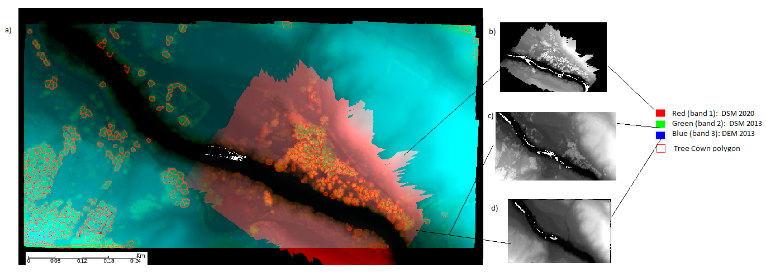

Figure 1: Building a layer stack of: 1) DEM (2013) and DSM (2013) generated via LIDAR and 2) WAIHOA-65m-FLT05-HQ.tif (a). The green regions within the red DSM 2020 band indicate vegetation loss. Whereby image on 1) top Band1 = DSM 2020 (b), center band 2= DSM 2013 (c) and bottom is Band 3= DEM 2013 (d). Received from ENVI 5.5. via build layer stack tool.

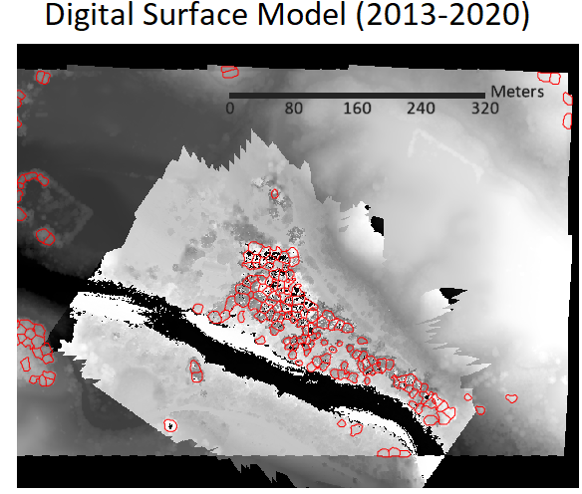

Figure 2: Digital Surface Model (DSM) from 2013 to 2020. Calculated by subtracting the 2013 DSM with 2020 DSM (from Figure 1 layer) via math band tool on ENVI 5.5.

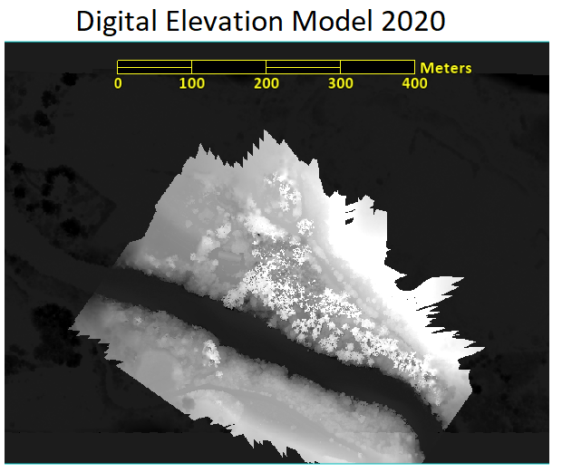

Figure 3: Digital Elevation model via drone in 2020. Calculated via Band math by subtracting DSM 2020 with DSM 2013 and adding difference with DEM 2013 ((DSM 2020 – DSM 2013) + DEM 2013) on ENVI 5.5.

Extra

* DTM=DIGITAL TRAN MODEL
* Sfm=structure from motion